CHIST-ERA Project
On-line Monitoring Platform: Guidelines for Project Coordinators

On-line monitoring platform
The projects funded from CHIST-ERA Calls are monitored by using the online monitoring tool (https://uefiscdi-direct.ro/).

Access data
Project members involved in the on-line monitoring process receives an user name (e-mail) and an individual access password via e-mail with which they can authenticate/log into the system and access their own space.

Home page
When accessing www.uefiscdi-direct.ro portal, after the authentication process, the main page that will be displayed contains the following information:

Structure of monitoring tool

Periodic Report Selection
The first part of the reporting section is dedicated to the general details of the project:
- Periodic report selection: selection of the periodic report number;
- Project identification: registration code, CHIST-ERA call topic, project acronym, project title.

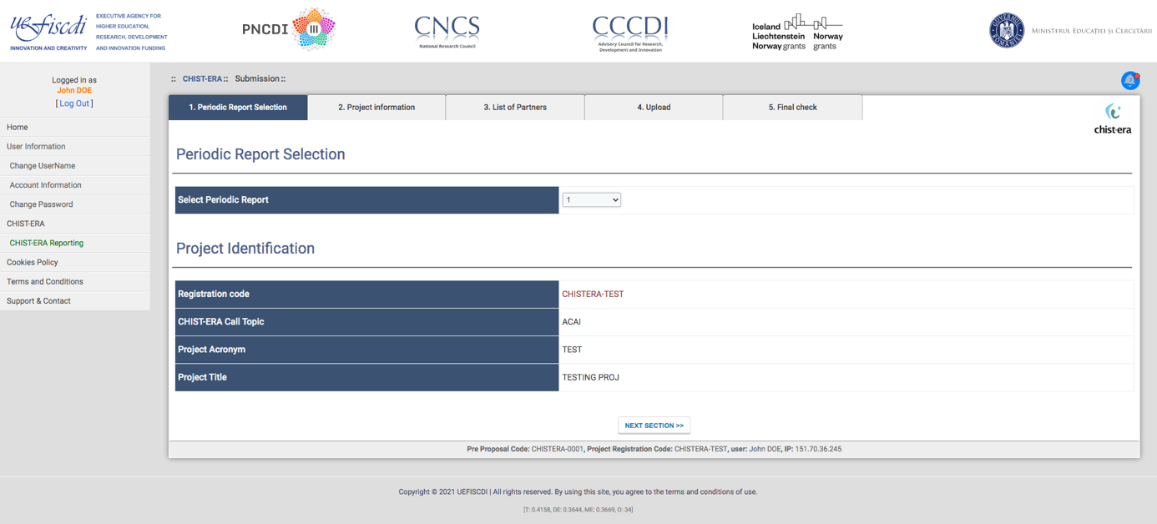

Project information
This area is dedicated to:
- Project start and end date and project duration;
- Number of institutions in the project;
- Project website;
- Publishable summary.
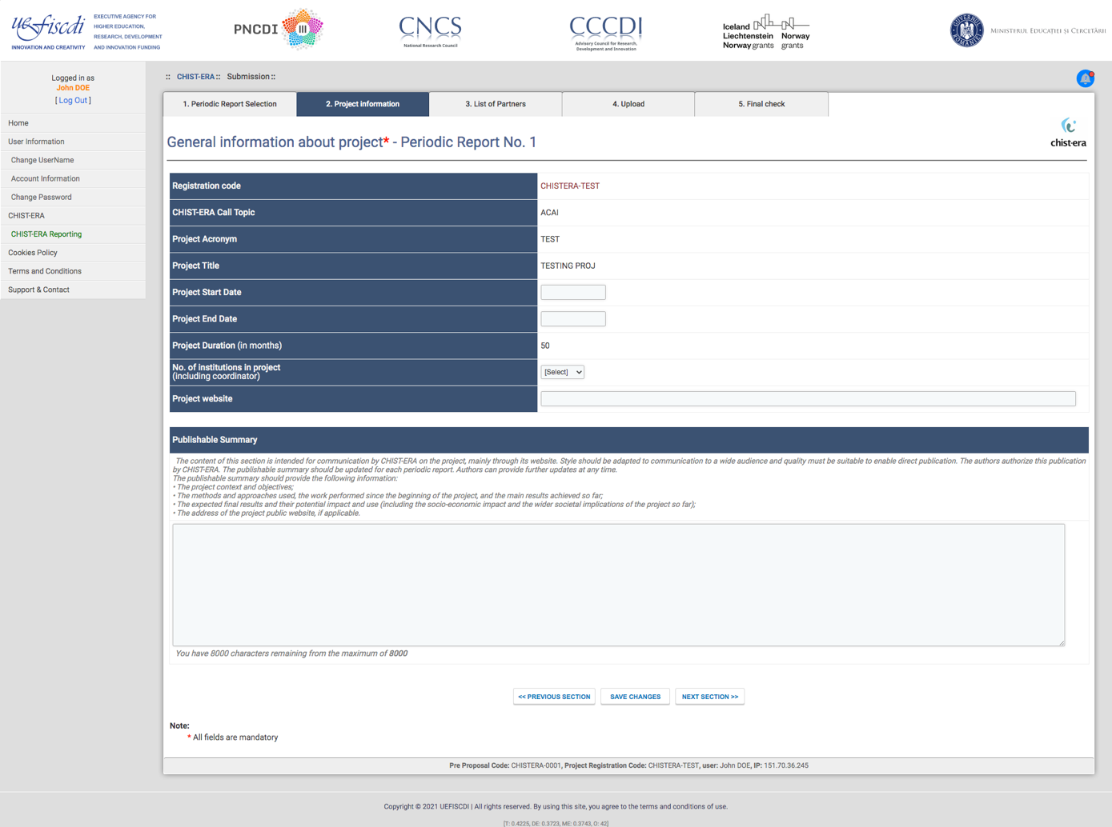

List of Partners
In this section the partners details (coordinator + other partners in the consortium) are provided. This information includes:
- Organisation details (country, name, department, type, city, address);
- Funding agency that funds the partner;
- Contract period (start and final date);
- Principal Investigator (first name, last name, gender, phone, email, position).
In the same section, the indication of the open science coordinator is requested.
The coordinator has to describe possible extension of the project duration requested to the CHIST-ERA secretariat and to the national funding organisations.
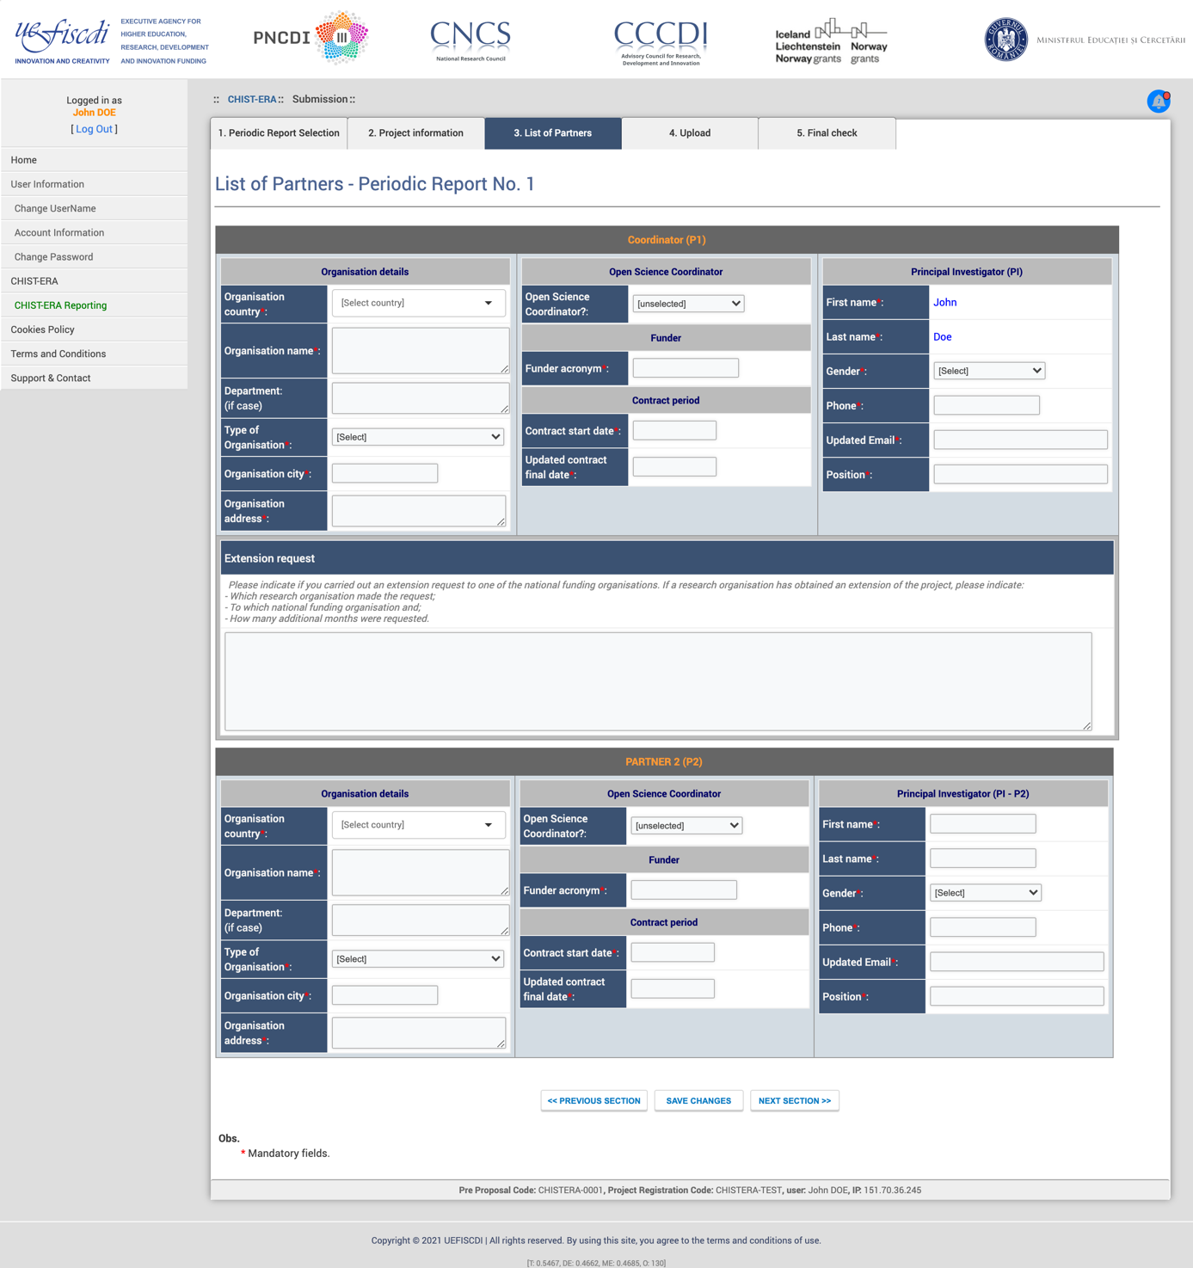

Project Periodic Report
The Project Periodic Report Template, available online to the project coordinators, includes the following sections (the project coordinators have to fill online the first two sections, while they have to provide the other three sections by filling in a document template and then upload it through the online monitoring tool):
1. Identification (call topic, project title and acronym, start/end date, website, coordinator info, list of participants)
- Publishable summary
- Progress report
  - Project objectives and activities implemented
  - Transnational collaboration
  - Significant events and results
  - Technology Readiness Level
  - Consortium meetings
  - Deliverables
  - Free comments
- Dissemination of results, exploitation, impact
  - Scientific publications (conferences/workshops, book chapters, etc.)
  - Exploitation plan
  - Exploitation overview (software, products, spin-offs, etc.)
  - Other dissemination of results
- Resources and Funding
  - Project level (from project start): PMs, total costs, % of requested budget
  - Comments on expenses

1.3.5 Periodic Report Upload
In this area the project coordinator can download the project periodic report template (containing sections 3, 4 and 5 as described above in Section 1.3.4) and then upload the filled in report.

Final check
In this section, the project coordinator can verify whether the information provided is complete in order to submit the report. In case there is missing information, a message will appear on the top of the page containing the errors encountered, e.g.:

If the information is complete, the following message appears and the project periodic report can be finalized. When finalizing the periodic report, the project coordinator receives a confirmation e-mail from the monitoring online tool.

